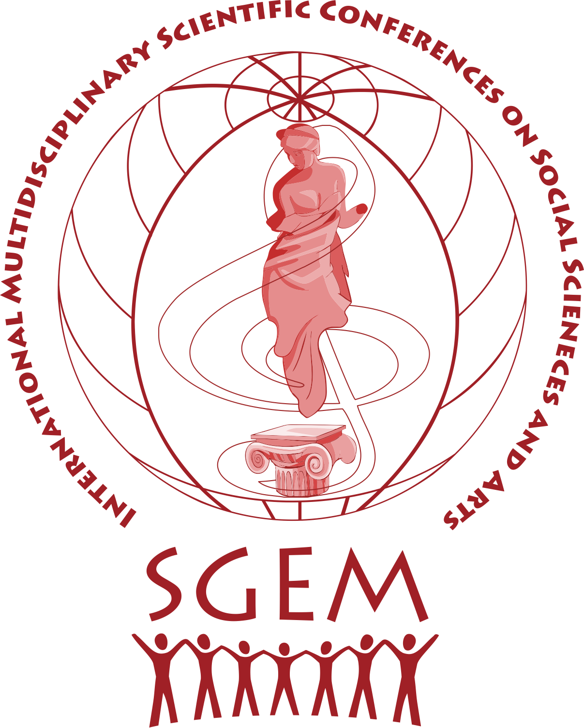
12th International Multidisciplinary
Scientific Conference on
SOCIAL SCIENCES, ARTS & humanities - Sws 2025

24-29 August 2025
Maritim Paradise Blue Congress Center
Albena Resort, Bulgaria
Phone: +43 (1) 412 0158
E-mails: scienceart@sgemsocial.org || sgemsocial@gmail.com
URL: https://www.sgemsocial.org/

R E G I S T R A T I O N F O R M

PROFILE DATA:

PhD Assist. Prof. Assoc. Prof. Assoc. Prof. DSc. Prof. Prof. DSc.
Mr. Mrs. Miss Name: your name, surname and family name here .
Organization/Company/University: name of your company here .
VAT / Tax Number: your company VAT Number here .
Passport N: if you need an invitation letter .
Address: your mailing address here ; City: city ;
State: state; Country: country here; ZIP (Post) code: ZIP code here; Phone: your phone number;
Fax: your fax number here ; E-mail: your e-mail here ;
URL: your web site address here .
REGISTRATION DATA:
* 2nd article fee: for Lecturer: FREE of charge; fore Publisher/ Virtual Presence: 229/262 euro
Registration | Conference Fee /excluding VAT/
Lecturer  1 paper + 1 paper BONUS * | 339 EURO / € 389 after 20th June 2025/
CoLecturer** | 309 EURO / € 355 after 20th June 2025/
Delegate | 309 EURO / € 355 after 20th June 2025/
Virtual Presence/Publisher  1 paper * | 229 EURO / € 262 after 20th June 2025/
Accompanying person | 59 EURO / € 69 after 20th June 2025/
** I am a co-author of participant: Name Family registered for participation at the Conference on Social Sciences and Arts & Humanities SWS 2025 as a LECTURER with SWS ID: please insert here the ID of the main LECTURER/co-author.
Day of arrival at the conference venue – Albena Co.: day / August /2025
Day of departure from Albena Co.: day / August, September /2025
I want to receive hard copy of the conference proceedings:
HARD Copy Book/1 vol (+ 79 euro postal fee)
No, I am Green;

PAPER SUBMISSION DATA:
I will participate with: number of articles here ;
Every author may submit up to 2 papers in total.

I know that papers must be written in English language /min 6 - max 8 (regular), 12 (long), 16 (extra-long) pages typewritten text/;
Remark: Kindly prepare your paper in accordance to the SWS paper template /Download template here/ and submit it in due time /See deadlines here/.

PAPER 1:
Paper Title: your paper title here ;
Section /list of topics/: scientific section here
Social Sciences Arts and Humanities
The paper will be presented as:
Oral presentation; Poster presentation; ZOOM session;
I need the SWS Team to print my POSTER material (+ 23 euro)
Please note, that only participants, who present their paper in ORAL/POSTER/Zoom session will receive a CERTIFICATE OF PARTICIPATION!

Kindly note, that each paper may have up to five authors, and we will need the following information for all authors:
Name & Family | University and Country | email / mobile | I read and accept the Publication Ethics & Malpractice Statement | Scopus/ORCID/PUBLON
Name & Family | University and Country | email / mobile | I read and accept the Publication Ethics & Malpractice Statement | Scopus/ORCID/PUBLON
Name & Family | University and Country | email / mobile | I read and accept the Publication Ethics & Malpractice Statement | Scopus/ORCID/PUBLON
Name & Family | University and Country | email / mobile | I read and accept the Publication Ethics & Malpractice Statement | Scopus/ORCID/PUBLON
Name & Family | University and Country | email / mobile | I read and accept the Publication Ethics & Malpractice Statement | Scopus/ORCID/PUBLON

PAPER 2 (free/complimentary second paper for Lecturer*)
Paper Title: your paper title here ;
Section /list of topics/ : scientific section here ;
Social Sciences Arts and Humanities
The paper will be presented as:
Oral presentation; Poster presentation; ZOOM session;
I need the SWS Team to print my POSTER material (+ 23 euro)

Kindly note, that each paper may have up to five authors, and information for all the authors should be provided as follows:
Name & Family | University and Country | email / mobile | I read and accept the Publication Ethics & Malpractice Statement | Scopus/ORCID/PUBLON
Name & Family | University and Country | email / mobile | I read and accept the Publication Ethics & Malpractice Statement | Scopus/ORCID/PUBLON
Name & Family | University and Country | email / mobile | I read and accept the Publication Ethics & Malpractice Statement | Scopus/ORCID/PUBLON
Name & Family | University and Country | email / mobile | I read and accept the Publication Ethics & Malpractice Statement | Scopus/ORCID/PUBLON
Name & Family | University and Country | email / mobile | I read and accept the Publication Ethics & Malpractice Statement | Scopus/ORCID/PUBLON

Declaration agreement:
- I have not published this paper anywhere before.
- I will not cause or involve in any sort of violence or disturbance with inside and outside of Conference.
- I and all my Co-author/s have provided original identity inside the Paper.
- I have read all information carefully provided in the Conference website for attending and publishing in ISCSS & ISCAH Conferences.
- I transfer the Copyright of my paper/s to the ISCSS & ISCAH Conferences (SWS Scholarly Society).
- I do hereby declare that all the information given by me is true and if at any moment it is found to be wrong my registration for event will be cancelled by the ISCSS & ISCAH Management.
Together with this form, I will also send paper abstract/keywords/section/biography.
All upper mentioned fees do not include VAT surcharge. I am free of VAT, only if my company VAT number is EU validated (check here).
I know that, due to corresponding bank charges for countries outside EU, a 15 Euro fee should be added to the total amount
Date: present date here Signature of Corresponding author: your name here

After filling in this registration form, please send it back with your RECENT FORMAL PHOTO (needed for the Conference Badge) together with ABSTRACT TEXT + KEYWORDS + SETION Name + SHORT BIOGRAPHY DATA via e-mail publish@sgemsocial.org

To pay by bank, first you may ask for an invoice-proform:
Bank attributes EURO:
Bank name: UniCredit Bulbank
Bank Swift BIC: UNCRBGSF
IBAN: BG49UNCR70001522198557
Bank address: 7 Sveta Nedelya Sq., 1000 Sofia, Bulgaria
Bank Account Holder/Beneficiary customer: STEF92 TECHNOLOGY Ltd.
Account Holder/Beneficiary Address: 51 Alexander Malinov Blvd., ent. B, Sofia, Bulgaria
Details of Charges: Sender's Charges
Remittance Information: SWS ID, Name Family, Invoice-Proform Number
FEES FOR BANK TRANSFER ARE AT PARTICIPANT’S (ORDERER) EXPENSE!

Online EMS System: “My payments” section main features:
- You can generate an automatic invoice -proform by yourself, for BANK payment
- You can pay online by CREDIT/DEBIT CARD
- You can download the ORIGINAL INVOICE, approximately a week after the payment

